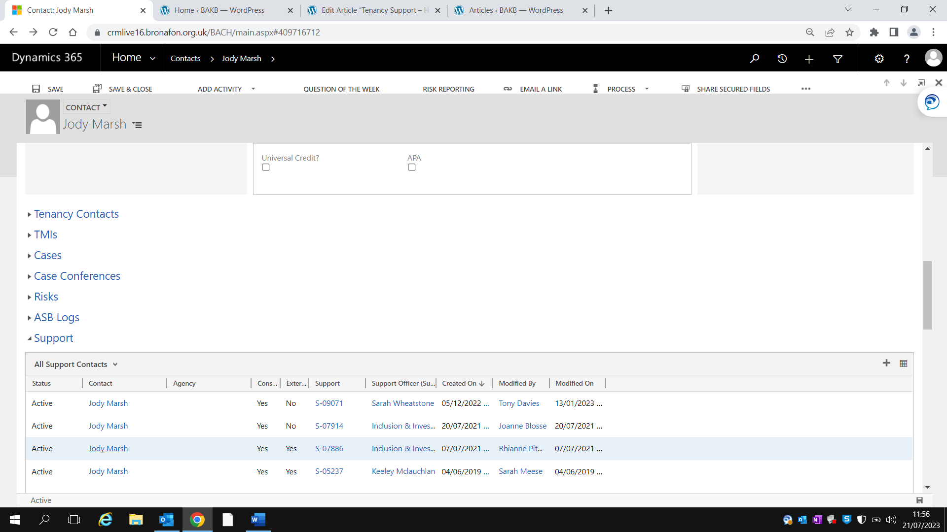

To find an active support record, go to the persons contact page and scroll down to the ‘support’ section. When you expand this you will be able to see the support records. To view the record, click the support case number.