Version 1.4

November 2019

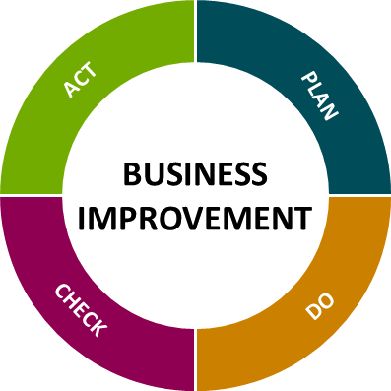

**Customer journey & process mapping**

# *Seeing Your Business Through Your Customers' Eyes*

## Map the journey that your customers take through your service.

Have you ever wondered what your organisation looks like to your customers? You might be shocked by the differences between how you see your organisation and how they do.

Put yourself in their shoes. When customers visit your office or website, or call you, what do they experience? When they receive a service, what information and support do they receive? And how do they get help if they need it?

Customer journey & process mapping helps you to map out the ways your customers experience your organisation and the services delivered. This guide shows you how to use this tool to improve the quality of service that you provide for customers.

## What Is Customer Journey & Process Mapping?

Customer journey & process mapping is a way to record, plot and analyse the interactions – or "touchpoints" – that a customer has with the organisation and the business processes that create the “touchpoints” and overall journey and experience.

It covers every interaction from initial contact to post-service follow-up. It can pinpoint problems or build on successes in your customers' experiences.

## How to Use Customer Journey Mapping

The following steps will guide you through the creation of an insightful customer journey and process map.

The following resources will be required to run a customer journey and process mapping session:

* Post-its (various colours and sizes)
* Marker pens
* Sellotape
* Long length of brown paper
* People involved in the process (Subject Matter Experts)

## 1. Define Your Objectives

What exactly are you looking to achieve? This information together with the scope of work can be found on the “Improvement Charter”.

This will help you understand the start and end point for the map together with the relevant “touchpoints”.

Identify why your customers want to/have to engage with your service. What do they want from it, what are their expectations, and do we deliver on them?

## 2. Start Mapping

Divide the brown paper lengthways into four as per the diagram below.

Customer Value

Thinking Feeling

Customer section

Process section

When you have divided the paper as shown you can start to map the processes that make up the service delivery and ensure that all customer touchpoints are clearly identified.

Customers interact with your organisation using a variety of "touchpoints." These may include face-to-face, email, social media, telephone calls, online chat services etc.

*Process is mapped in the ‘Process section’ with all customer touchpoints in the ‘Customer section’*

When you are mapping it may be beneficial to assign specific colour post-its to specific roles, this can help to identify all the hand-offs in our internal process.

## 3. Assess Your Customer "Touchpoints"

Once you have identified the “touchpoints” created by the processes within the service delivery, it’s time to think how they affect your customer.

Through each step of the process and the identified “touchpoints” what value is there to your customer? – this should populate the ‘Customer value’ section.

How does each step of the process or “touchpoint” leave the customer feeling or thinking, this should be logged in the ‘Thinking Feeling’ section. These entries should show how success leaves your customer thinking and feeling and also if the service fails how they are left thinking or feeling.

## 4. Validate Your Results

When your map is complete it will be necessary to have its contents validated. This can be actioned via the following methods:

* Focus group
* Customer forum
* Colleague verification

There is no better way of having a customer journey map validated than discussing with customers that have received that service.

The map may need to be amended during the validation process to ensure the final draft is as accurate as possible.

## 5. Analyse Your Map

Now you have a completed customer journey & process map it is time to analyse the map for improvements that will help to achieve your objectives.

What should you be looking for within the map that could improve the service delivery and the resulting customer experience?

* Do we need to deliver the service?
* Any part of the process that does not bring value should be investigated
  + Does it need to be there?
  + Will the service be better without it?
* Can any parts of the process be automated reducing the time to deliver or allowing self-service functionality?
* Are the Hand-offs necessary?
  + Could one role do it all?
  + Would it be more efficient?
* Are we bombarding the customer with too much information?
* Are we giving the customer the correct information throughout the journey?
* Is the customer receiving the information through their preferred method?

The process should be reviewed for waste and the use of the **5Whys** may assist in identifying if steps are value added or not.