Contract Holder Accident / Incident Report Form (Part One)
(To be filled in with contract holder by relevant Community Housing Manager)

When recording information about how the incident happened use only the objective facts that you have gathered. It is important for investigations that photographs of the scene, defects, damage etc are taken and forwarded with the report.

Ref Code: AIR___________

Step 1: Contract holder Details
Contract holder/Resident Name:

Contract holder/Resident Address:
Contact Number(s): | Email Address:

Step 2: Describe the accident/incident
Date of accident/Incident: |  | Time of accident/incident:
Location and address of accident/incident: |  | Weather conditions:  (if applicable)
Name of witnesses (if any):
(Please note: If a member of public is involved as a witness or involved in the incident contact details including address and phone number should be obtained)

Describe the events leading up to and including the accident/incident:
(When recording information about how the accident happened use only the objective facts that you have gathered) continue on separate sheet if necessary)

What parts of your body were injured? (Please specify injury) | Did you receive treatment for your injury?  (Give details of Dr, First Aider, medication, stay in hospital etc.)
If yes, please give name and address details of doctor:

Step 3: Your signature
I give my permission for this information to be shared of this accident record with a Third Party (H&S/Insurance)

Contract holder Signature:______________________________ Date:_______________

Where an individual has consented to disclosing their information, Bron Afon can share the following information with health and safety representatives/insurers.

Employee Name filling in the form (please print): | Date:
Employee Signature:

Please pass Part 1 to the relevant Community Housing Officer and Surveyor, Insurance Team and copy to the Health and Safety Team within 24 hours.

Part 2 (investigation) must be completed within 48 hours of the incident (if minor) and 5 working days if more complex investigation required

Step 1: Injured Person
Name:
Address:

Part of body affected: (circle all that apply)  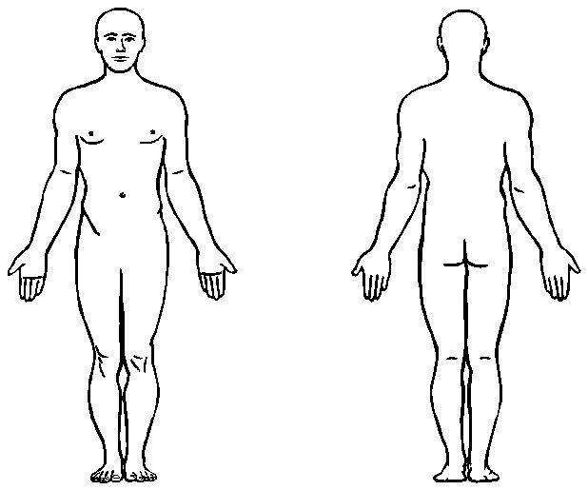 | Nature of injury: (please tick applicable)  - Abrasion/scrapes  - Amputation  - Broken bone  - Bruise  - Burn (heat)  - Burn (chemical)  - Concussion  - Crushing injury  - Cut, laceration, puncture  - Hernia  - Illness  - Sprain/strain  - Damage to a body system:  - Other _________________
Has this injury resulted in a hospital stay?  Yes No  If unsure at present, please seek advice from HR or H&S or consult the Accident reporting procedure Please note if hospital stay is needed due to the incident for this may be RIDDOR reportable | Is this a RIDDOR reportable incident?  Yes No  (please seek advice from the  Health and Safety Manager before reporting)
 | RIDDOR report reference:

Contract holder Accident/Incident Report Form Ref Code: AIR:___________

Post Investigation Form: Part Two
(To be filled in by employee investigating)
Part 2 (investigation) must be completed and returned to the Health and Safety Team and Insurance Team within 48 hours of the incident (if minor) and 5 working days if more complex investigation required
When recording information about how the incident happened use only the objective facts that you have gathered. It is important for investigations that photographs of the scene, defects, damage etc are taken and forwarded with the report.

Step 2: Describe the incident
Exact location of the incident: |  |  | Date:  Time:
Name of witnesses (if any):

No. of attachments: | Written witness statements: | Photographs: |  | Maps/drawings:
Describe, step by step the events that led up to the injury (When recording information about how the accident happened use only the objective facts that you have gathered) (Can be continued on separate sheet)

Step 3: Why did the incident happen?
Unsafe conditions (tick all that apply)  - Unguarded hazard  - Unsafe lighting  - Unsafe ventilation  - Outstanding H&S repair/maintenance  - Uneven surface  - Tools or equipment left unsafely  - Other ______________ | Unsafe acts by people (tick all that apply)  - Acting without permission  - Making a safety device inoperative  - Knowingly using defective equipment  - Unsafe lifting  - Unauthorised maintenance by contract holder  - Taking an unsafe position or posture  - Other____________________
Why did the unsafe conditions exist?
(were there steps Bron Afon could have taken to ensure the unsafe conditions didn’t exist?)

Why did the unsafe acts occur?

Were the unsafe conditions or acts reported prior to the incident?
(please circle) Yes No

Have there been similar incidents prior to this one?
(please circle) Yes No

What in your opinion is the root cause of the incident ? (please use the 5 Whys to find out the root cause)

- Human failings e.g. slips or lapses of memory, errors of judgment
- Job Factors (time available, inadequate procedures, poor supervision, unsuitable RAMS)
- Human Factors (physical ability, fatigue)
- Organisational Factors (work pressures, supervision, procedures)
- Other (please state)

What were the weather conditions and did they play a part in this incident?

Step 4: How can future incidents be prevented?
Lessons Learnt

What changes can you suggest to prevent this incident from happening again.

How will you share this information with your colleagues to ensure learning lessons are taken forward?)

Post Investigation Action Plan - What actions should be (or have been) put in place to carry out the suggested changes above? (Continue on separate sheet if required)
Action | Who | By When | Complete (Y/N)
Please note it is manager’s responsibility to ensure this action plan is closed down.
Please also update Insurance and H&S with a copy of the closed/final version

Step 5: Who completed and reviewed this form? (please print)
Print Name:  Signature:  Date: | Job Title:  Department:  Manager:
Name: Signature:

Step 6: Post Investigation Sign Off (Senior Manager)
Please comment on the accident /incident or any other observations

What action will you take to make sure lessons are learned & shared to prevent a similar incident happening again?

Senior Manager signature: | Date:

Part 2 (investigation) must be completed and returned to the Insurance and Health and Safety Team within 48 hours of the incident (if minor) and 5 working days if more complex investigation required

This will be retained by the Health and Safety Team for audit purposes only.

