[](https://bronafon.interactgo.com/home/41)Version 1.0

october 2020

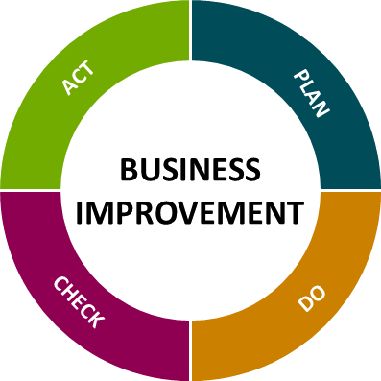

**a3 problem solving – A quick guide**

# *structured, focussed improvement on a single page*

**A3 PROBLEM SOLVING**

1. WHAT IS IT?

The short answer is it’s a structured method to solve a problem and document the different steps in that process.

It’s also used for things like reporting the status of a project and proposing changes to a policy.

Like many things associated with lean manufacturing, A3 was created in Japan by Toyota as part of the Toyota Production System (TPS). Of course, it’s now used widely throughout the world.

A3 is the size of paper that was originally used to document the A3 problem-solving method.

1. WHAT’S THE POINT OF USING THE A3 PROCESS?

The A3 problem-solving method provides a simple, logical, formulaic way to solve a problem and to communicate about the problem to coworkers.

Other nice benefits of the A3 process are that it’s organiSed, and it focuses on objectives, it forces the A3 report writer to be concise and stick to what’s truly critical.

Finally, it’s an easy thing to learn and to complete as part of a small team or on your own.

1. WHAT ARE THE DIFFERENT STEPS IN THE A3 PROBLEM SOLVING METHOD

Depending on whom you talk to, you’ll see slightly different numbers of steps in the A3 method. Here’s how we like to think about it.

1. Background
2. Current situation
3. Target or goal
4. Root-cause analysis
5. Countermeasures
6. Implementation plan
7. Implement
8. Verification
9. Follow up–share the story and update standardized work

Let’s look at each step in more detail.

**Step 1: Problem Description**

The first step is to clearly identify and briefly describe the problem. This is the problem statement from your Improvement Charter.

**Step 2: Current Situation**

Once you’ve described the problem, explain the current situation and context the issue is situation in. Use data and statistics when possible.

During this step, you might want to create a map of the processes that surround, are near, or influence the issue.

**Step 3: Target/Goal**

Define goals for what you’d like the desired end state to be.

Keep in mind that as you continue through the A3 process, and as you learn more, you may benefit from returning to this step and reformulating the goals.

**Step 4: Root-Cause Analysis**

Now, try to find the root cause of the problem. Keep in mind that often, the “root cause” is often not just one cause but a collection of interacting factors.

Classic methods in your improvement toolbox for determining root cause include the 5 Whys?. In addition, keep in mind that you’ll benefit from applying systems thinking, as many workplace problems are really systemic in nature.

**Step 5: Countermeasures**

Propose potential solutions and explain how they’d lead to they’ll reach your goal/target.

**Step 6: Implementation Plan**

Create a plan that includes all steps/actions necessary to implement the countermeasure. Note who’s responsible for each step/action/task and when it should be completed.

Then implement, perhaps on a small scale as a “beta test.”

**Step 7: Verification**

Measure to see if the countermeasure actually worked.

If the plan didn’t work, create a new plan, implement that, and then check the results again.

**Step 8: Follow Up–Share the Results and Updated Standardised Work**

If the plan did work, leading to a positive result, communicate that to the rest of your organisation and integrate the change into standardised work.

1. HOW DOES THE A3 PROBLEM SOLVING METHOD ‘MAP’ TO THE PDCA CYCLE?

The A3 problem-solving method can be nicely “mapped” to the different phases of the PDCA cycle, as shown below.

|  |  |  |  |
| --- | --- | --- | --- |
| **PLAN** | **DO** | **CHECK** | **ACT** |
| Problem Description  Current situation  Target or goal  Root-cause analysis  Countermeasures  Implementation plan | Implement | Verification | Follow up–share the story and update standardised work |

1. **PROBLEM DESCRIPTION**

**2. CURRENT SITUATION/CURRENT STATE**

**3. GOAL OR TARGET IMPROVEMENT**

**4.ROOT CAUSE ANALYSIS**

**5. COUNTERMEASURES**

**6. IMPLEMENTATION PLAN**

**7. CHECK RESULTS - VERIFY**

**8. UPDATE STANDARD WORK**

**TITLE: LOCATION/DEPARTMENT: AUTHOR: DATE:**